**Test Case Document**

|  |  |
| --- | --- |
| **Project:** | **Company Management System** |
| Date: | 09/08/2019 |
| Client: | Dream Squad |
| Group No: | 12 |
| Author: | Shehani Gamage (Quality Assurance) |
| Version: | 2.0 |

|  |  |
| --- | --- |
| Test Case | |
| Test Case Description: Welcome | |
| Test Case ID: | 01 |
| Precondition | Run the System |
| Input | Click Get Started button |
| Actions | Click Get Started button |
| Expected result | The system should open the Login interface |
| Actual Result | The system opens the Login interface |
| Pass/Fail | Pass |

|  |  |
| --- | --- |
| Test Case | |
| Test Case Description: User Login | |
| Test Case ID: | 02 |
| Precondition | Database Connection |
| Input | Username, Password |
| Actions | Checking username and password from the database |
| Expected result | Correct username and password should allow the user to login to the system.  If username and password is incorrect, the system should prompt an error message |
| Actual Result | Login is successful.  The system displays an error message if username or password is wrong are wrong. |
| Pass/Fail | Pass |

|  |  |
| --- | --- |
| Test Case | |
| Test Case Description: Forgot password | |
| Test Case ID: | 03 |
| Precondition | Database Connection |
| Input | Username, New Password, Confirm password, Security question, Answer to the security question |
| Actions | Click on forgot password, select security question |
| Expected result | When the user selects a security question and gives the correct answer system should allow changing password.  If the answer to the security question is wrong, the system should prompt an error message.  An error message should be displayed if the new password and confirm new password do not match.  Security questions should not be loaded if the username is wrong. |
| Actual Result | When the user selects a security question and gives the correct answer system allows changing password.  If the answer to the security question is wrong, the system prompts an error message.  If the new password and confirm new password does not match, the system displays an error message.  Security questions do not load if the username is wrong. |
| Pass/Fail | Pass |

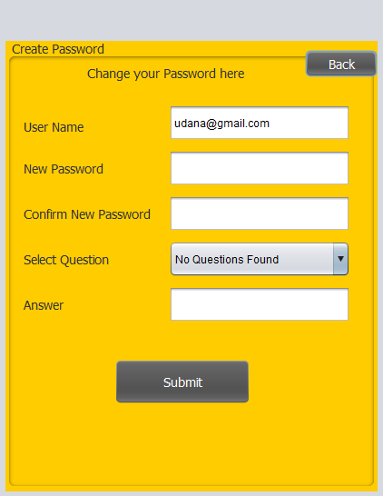

|  |  |
| --- | --- |
| Test Case | |
| Test Case Description: Entering Add/Update Manager Interface | |
| Test Case ID: | 04 |
| Precondition | Logged in to the system as an admin, Database Connection |
| Input | Click the Add/Update Manager button |
| Actions | Click the Add/Update Manager button |
| Expected result | The system should open the Add/Update Manager interface |
| Actual Result | The system directs the user to Add/Update Umpire interface |
| Pass/Fail | Pass |

|  |  |
| --- | --- |
| Test Case | |
| Test Case Description: Entering Search/Delete Manager Interface | |
| Test Case ID: | 05 |
| Precondition | Logged in to the system as an admin, Database Connection |
| Input | Click the Search/Delete Manager button |
| Actions | Click the Search/Delete Manager button |
| Expected result | The system should open the Search/Delete Manager interface |
| Actual Result | The system directs the user Search/Delete Manager interface |
| Pass/Fail | Pass |

|  |  |
| --- | --- |
| Test Case | |
| Test Case Description: Entering Manage Admin Account Interface | |
| Test Case ID: | 06 |
| Precondition | Logged in to the system as an admin, Database Connection |
| Input | Click Manage Admin Account button |
| Actions | Click the Manage Admin Account button |
| Expected result | The system should open the Manage Admin Account interface |
| Actual Result | The system directs the user to Manage Admin Account interface |
| Pass/Fail | Pass |

|  |  |
| --- | --- |
| Test Case | |
| Test Case Description: Entering Edit/Delete Admin Account Interface | |
| Test Case ID: | 07 |
| Precondition | Logged in to the system as an admin, Database Connection |
| Input | Click the Edit/Delete Admin Account button |
| Actions | Click the Edit/Delete Admin Account button |
| Expected result | The system should open the Edit/Delete Admin Account interface. |
| Actual Result | The system directs the user to Edit/Delete Admin Account interface. |
| Pass/Fail | Pass |

|  |  |
| --- | --- |
| Test Case | |
| Test Case Description: Entering the Change Password Interface | |
| Test Case ID: | 08 |
| Precondition | Logged in to the system as an admin, Database Connection |
| Input | Click the Change Password button |
| Actions | Click the Change Password button |
| Expected result | The system should open the Change Password interface |
| Actual Result | The system directs the user to the Change Password interface. |
| Pass/Fail | Pass |

|  |  |
| --- | --- |
| Test Case | |
| Test Case Description: Admin Logout | |
| Test Case ID: | 09 |
| Precondition | Logged in to the system as an admin, Database Connection |
| Input | Click the Logout button |
| Actions | Click the Logout button |
| Expected result | The system should open the Login interface. |
| Actual Result | The system directs the user to the Login interface. |
| Pass/Fail | Pass |

|  |  |
| --- | --- |
| Test Case | |
| Test Case Description: Entering Client Management Interface | |
| Test Case ID: | 10 |
| Precondition | Logged in to the system as a manager, Database Connection |
| Input | Click the Add Client button |
| Actions | Click the Add Client button |
| Expected result | The system should open the Client Manage interface |
| Actual Result | The system directs the user to Client Manage interface |
| Pass/Fail | Pass |

|  |  |
| --- | --- |
| Test Case | |
| Test Case Description: Entering Finance Management Interface | |
| Test Case ID: | 11 |
| Precondition | Logged in to the system as a manager, Database Connection |
| Input | Click the Finances button |
| Actions | Click the Finances button |
| Expected result | The system should open the Finance Manage interface |
| Actual Result | The system directs the user to Finance Manage interface |
| Pass/Fail | Pass |

|  |  |
| --- | --- |
| Test Case | |
| Test Case Description: Entering Project Details Interface | |
| Test Case ID: | 12 |
| Precondition | Logged in to the system as a manager, Database Connection |
| Input | Click the Projects button |
| Actions | Click the Projects button |
| Expected result | The system should open the Project Management interface |
| Actual Result | The system directs the user to the Project Management interface |
| Pass/Fail | Pass |

|  |  |
| --- | --- |
| Test Case | |
| Test Case Description: Entering Suppliers and products Interface | |
| Test Case ID: | 13 |
| Precondition | Logged in to the system as a manager, Database Connection |
| Input | Click the Suppliers and Products button |
| Actions | Click the Suppliers and Products button |
| Expected result | The system should open the Supplier and Product Management interface |
| Actual Result | The system directs the user to the Supplier and Product Management interface |
| Pass/Fail | Pass |

|  |  |
| --- | --- |
| Test Case | |
| Test Case Description: Entering Manage Employees Interface | |
| Test Case ID: | 14 |
| Precondition | Logged in to the system as a manager, Database Connection |
| Input | Click the Employees button |
| Actions | Click the Employees button |
| Expected result | The system should open the Employee Management interface |
| Actual Result | The system directs the user to the Employee Management interface |
| Pass/Fail | Pass |

|  |  |
| --- | --- |
| Test Case | |
| Test Case Description: Entering View Profile Interface | |
| Test Case ID: | 15 |
| Precondition | Logged in to the system as a manager, Database Connection |
| Input | Click the View Profile button |
| Actions | Click the View Profile button |
| Expected result | The system should open the Employee Profile interface |
| Actual Result | The system directs the user to the Employee Profile interface |
| Pass/Fail | Pass |

|  |  |
| --- | --- |
| Test Case | |
| Test Case Description: Entering Shipping Details Interface | |
| Test Case ID: | 16 |
| Precondition | Logged in to the system as a manager, Database Connection |
| Input | Click the Shipping button |
| Actions | Click the Shipping button |
| Expected result | The system should open the Shipping Details interface |
| Actual Result | The system directs the user to the Shipping Details interface |
| Pass/Fail | Pass |

|  |  |
| --- | --- |
| Test Case | |
| Test Case Description: Manager Logout | |
| Test Case ID: | 17 |
| Precondition | Logged in to the system as a manager, Database Connection |
| Input | Click the Logout button |
| Actions | Click the Logout button |
| Expected result | The system will open the Login interface. |
| Actual Result | The system directs the user to the Login interface. |
| Pass/Fail | Pass |

|  |  |
| --- | --- |
| Test Case | |
| Test Case Description: Add/Update Manager Details | |
| Test Case ID: | 18 |
| Precondition | Logged in to the system as an admin, Database Connection, Open Add/Update Manager interface |
| Input | Full name, NIC, Address, DOB, Email, Date joined, User level, Salary, EPF rate, Allowed leaves, Contact no, Username, Password, Security Question, Answer to the security question |
| Actions | Inserting data, Validating entered data, Clicking submit button |
| Expected result | If all data are entered correctly, data should be successfully entered to database and system should display confirmation-by-confirmation box.  If data entered are incorrect or fields are empty system should display an error message. |
| Actual Result | If all data are entered correctly, data successfully enter into the database.  The system displays a confirmation box when data goes to the Database.  If data entered are incorrect or fields are empty, the system displays an error message. |
| Pass/Fail | Pass |
| Test Case | |
| Test Case Description: Search/Delete Manager Details | |
| Test Case ID: | 19 |
| Precondition | Logged in to the system as an admin, Database Connection, Open Search/Delete Manager interface |
| Input | Name |
| Actions | Inserting data, Clicking search/delete button |
| Expected result | If entered data matches with data in the database tables should load.  If data entered are incorrect tables should not be loaded.  If the user clicks on the delete button, the system should delete data about the user. |
| Actual Result | If entered data matches with data in the database, tables load details about managers.  If data entered are incorrect table does not load data.  If the user clicks on the delete button, the system deletes data about the user. |
| Pass/Fail | Pass |

|  |  |
| --- | --- |
| Test Case | |
| Test Case Description: Admin Manage Details | |
| Test Case ID: | 20 |
| Precondition | Logged in to the system as an admin, Database Connection, Open Admin Manager interface |
| Input | Full Name, NIC, Username, Password (add new admin)  Name (search) |
| Actions | Inserting data, Validating entered data, Clicking submit button, Search admins by username |
| Expected result | If all data are entered correctly, data should be successfully entered to database and system should display a confirmation-by-confirmation box.  If data entered are incorrect or fields are empty system should prompt an error message.  If entered username matches with data in the database tables should load admin details.  Admin login history table should load the user’s last logging details.  Admins online table should load details of admins currently online. |
| Actual Result | If all data are entered correctly, data will be successfully entered into a database and shows a confirmation box.  If entered data is incorrect system displays an error message.  If the user search by username, the system shows admin ID and Name.  The system will load the admins' login history table.  The system will show Admins online at the time. |
| Pass/Fail | Pass |

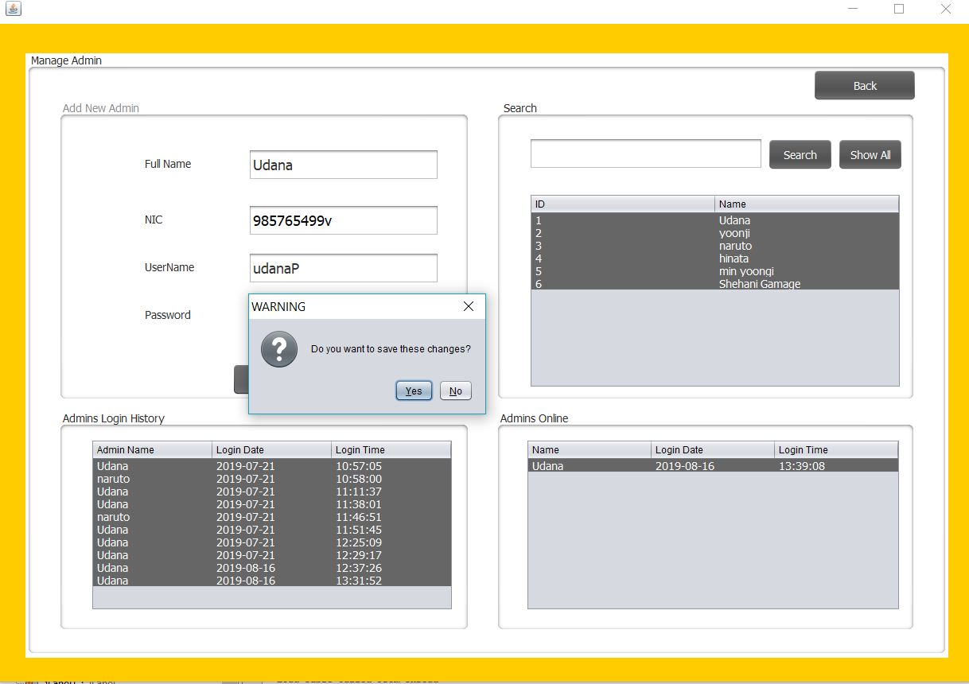

|  |  |
| --- | --- |
| Test Case | |
| Test Case Description: Edit/Delete Admin Profile | |
| Test Case ID: | 21 |
| Precondition | Logged in to the system as an admin, Validating entered data, Database Connection, Open Admin Profile Interface |
| Input | Full Name |
| Actions | Select Full name |
| Expected result | If the user selects a name, the system should show the details of an admin and allows for editing or deleting profile.  If the user clicks on the edit button, an action confirmation message should appear.  If a user clicks delete button action confirmation message should appear. |
| Actual Result | When a user selects a name, the system shows details of selected user an allows for editing or deleting profile.  The system shows action confirmation messages. |
| Pass/Fail | Pass |

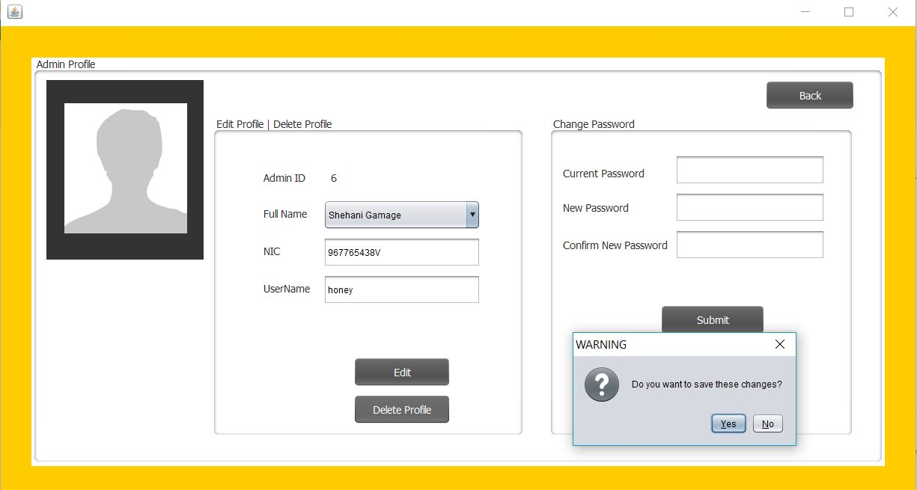

|  |  |
| --- | --- |
| Test Case | |
| Test Case Description: Inserting values to Admin Change Password | |
| Test Case ID: | 22 |
| Precondition | Logged in to the system as an admin, Validating entered data, Database Connection, Open Admin Profile Interface |
| Input | Current Password, new Password |
| Actions | Inserting data, compare with database data |
| Expected result | If the current password matches with database data and new password and confirms new password inputs are matched, the system should update the database.  If data entered is incorrect system should prompt an error message. |
| Actual Result | If the current password matches with database data, and new password and confirms new password inputs are matched, the system updates the database.  If the entered password is incorrect system displays an error message. |
| Pass/Fail | Pass |

|  |  |
| --- | --- |
| Test Case | |
| Test Case Description: Add/Search/ Edit /Delete Client details | |
| Test Case ID: | 23 |
| Precondition | Logged in to the system as a manager, Database Connection, Open Client Management interface |
| Input | Full name, Address, NIC, Email, Contact No, Priority |
| Actions | Inserting data, Validating entered data. Click submit/search/update/delete button |
| Expected result | If all data is entered correctly, data will be successfully entered to database and system will give confirmation-by-confirmation box.  If a field is empty system will show an error message.  If data entered is incorrect system will display an error message.  If the user clicks the search button, all client details will display on the table.  If the search by name, tables should load details about searched client name.  If the user clicks on a name in the table, details should be displayed in text boxes.  If the user clicks on a name and clicks the update button, the client profile interface should be opened and allows to update details.  If the user clicks on a name and clicks the delete button, client details should be deleted from the database.  If the user clicks on the delete button, a confirmation box will be displayed. |
| Actual Result | If all data is entered correctly, data will be successfully entered to database and system displays confirmation-by-confirmation box.  If a field is empty system displays an error message.  If data entered is incorrect system displays an error message.  If the user clicks the search button, all client details display on the table.  If the user search by name, table loads details about searched client name.  If the user clicks on a name in the table, details displays in text boxes.  If the user clicks on a name and clicks the update button, the client profile interface opens and allows to update details.  If the user clicks on a name and clicks the delete button, client details delete from the database.  If user click deletes button confirmation box displays. |
| Pass/Fail | Pass |

|  |  |
| --- | --- |
| Test Case | |
| Test Case Description: Finance Management | |
| Test Case ID: | 24 |
| Precondition | Logged in to the system as a manager, Database Connection, Open Finance Management interface |
| Input | Type, Date, Description, Amount |
| Actions | Inserting data, Validating entered data, clicking the submit button,  Selecting starting and end dates, Clicking the Generate Report button |
| Expected result | If the entered data is correct data should be added into the database.  If a text box is an empty or invalid type of data system should show an error message.  The system should show a total no of income, expenses, and total balance every time a new transaction happens.  When a new transaction added to the system, the recent transaction table should update.  If a user selects the start date and end date and clicks on the generate report button, the transaction table should show transaction details between the selected period and should display a pie chart.  If the user clicks the email pie chart button, it should send an email to the user. |
| Actual Result | If the entered data is correct data add into the database.  If a text box is an empty or invalid type of data system displays an error message.  The system displays a total no of income, expenses, and total balance every time a new transaction happens.  When a new transaction added to the system, the recent transaction table is updated.  If a user selects the start date and end date and clicks on the generate report button, the transaction table displays transaction details between the selected period and displays a pie chart.  The system does not send an email of the pie chart to the user. |
| Pass/Fail | Fail |

|  |  |
| --- | --- |
| Test Case | |
| Test Case Description: Project Management | |
| Test Case ID: | 25 |
| Precondition | Logged in to the system as a manager, Database Connection, Open Project Management interface |
| Input | Project name, Type, Priority, Deadline, Client name, Assigned Employee, Budget, Status |
| Actions | Inserting data, Validating entered data, clicking Add project/Search/Update/Delete buttons, Clicking extract Project |
| Expected result | If all data is entered correctly, data should be successfully entered into the database.  If data is entered into the database, the system should load tables.  If a field is empty or invalid data type, the system should display an error message.  If user search by project name table should load and displays data about the project.  If the user clicks the search button, all project details should be displayed.  If the user clicks on a name and clicks the update button, the project details should be displayed on the boxes and should allow updating details.  If the user clicks on a name and clicks the delete button, the system should show a confirmation box and allow deleting.  If the user clicks on the extract project button, a PDF of all project details should create.  After the PDF created if the user clicks the email PDF button, email of PDF should send to the user’s account. |
| Actual Result | If all data is entered correctly, data successfully enter into the database.  When data is entered into the database, system loads tables.  If a field is empty or invalid data type, the system displays an error message.  If user search by project name table loads and displays details about the project.  When the user clicks the search button, all project details display on the table.  If the user clicks on a name and clicks the update button, the project details display on the boxes and allow for updating details.  If the user clicks on a name and clicks the delete button, the system displays a confirmation box and allows deleting.  If the user clicks on the extract project button, a pdf of all project details creates.  Email of PDF does not send to the email. |
| Pass/Fail | Fail |

|  |  |
| --- | --- |
| Test Case | |
| Test Case Description: Supplier Management | |
| Test Case ID: | 26 |
| Precondition | Logged in to the system as a manager, Database Connection, Open Supplier and Product Management interface |
| Input | Full name, Address, Email, Contact |
| Actions | Inserting data, Validating entered data, clicking Submit/Search/Update/Delete/View all buttons |
| Expected result | If all data is entered correctly, the system will show a confirmation box before adding data into the database.  If the product already exists in the database show a warning.  Data will be successfully entered into the database.  If a field is empty system will show an error message.  If data entered to the database systems loads tables.  Load tables from the database when, user search supplier by name.  Load tables if the user clicks on view all button.  Display data on text boxes if the user clicks on supplier name on the table.  When updating, the system will show a confirmation box before update data into the database.  When the entered data is deleting, the system will show a confirmation box before deleting data from the database. |
| Actual Result | If all data is entered correctly, the system will show a confirmation box before adding data into the database.  If the product already exists in the database show a warning.  Data will be successfully entered into the database.  If a field is empty system will show an error message.  When data is entered to the database systems loads tables.  Load tables from the database when the user searches suppliers by name.  Load tables if the user clicks on view all button.  Display data on text boxes if the user clicks on supplier name on the table.  When updating, the system will show a confirmation box before update data into the database.  When the entered data is deleting, the system will show a confirmation box before deleting data from the database. |
| Pass/Fail | Pass |

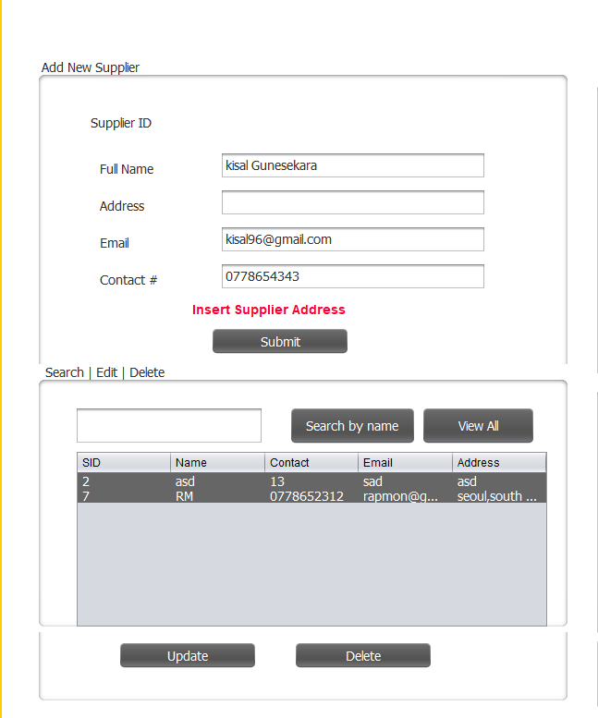

|  |  |
| --- | --- |
| Test Case | |
| Test Case Description: Product Management | |
| Test Case ID: | 27 |
| Precondition | Logged in to the system as a manager, Database Connection, Open Supplier and Product Management interface |
| Input | Product name, Supplier, Quantity, 1 item cost |
| Actions | Inserting data, Validating entered data, clicking Submit/Search/Update/Delete/View all buttons |
| Expected result | If all data is entered correctly, the system will show a confirmation box before adding data into the database.  If the product already exists in the database show a warning.  Data will be successfully entered into the database.  If a field is empty system will show an error message.  If data entered to the database systems loads tables.  Load tables from the database when user search supplier by name.  Load tables and display all product details, if the user clicks on view all button.  Display data on text boxes if the user clicks on products on the table.  When updating, the system will show a confirmation box before update data into the database.  When the entered data is deleting, the system will show a confirmation box before deleting data from the database. |
| Actual Result | When data is entered correctly, the system will show a confirmation box before adding data into the database.  If the product already exists in the database show a warning.  Data will be successfully entered into the database.  If a field is empty system will show an error message.  If data entered to the database systems loads tables.  Load tables from the database when user search supplier by name.  Load tables and display all product details if the user clicks on view all button.  Display data on text boxes if the user clicks on products on the table.  When updating, the system will show a confirmation box before update data into the database.  When the entered data is deleting, the system will show a confirmation box before deleting data from the database. |
| Pass/Fail | Pass |

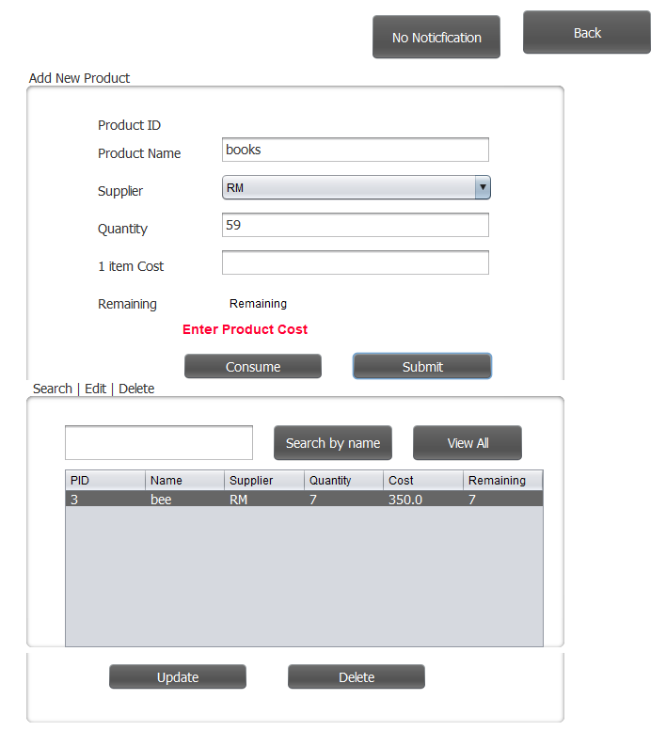

|  |  |
| --- | --- |
| Test Case | |
| Test Case Description: Employee Management | |
| Test Case ID: | 28 |
| Precondition | Logged in to the system as a manager, Database Connection, Open Supplier and Product Management interface |
| Input | Full name, Address, NIC, DOB, Email, Date joined, User Level, Salary, EPF rate, Allowed leaves, Contact no |
| Actions | Inserting data, Validating entered data, clicking Submit/Search/Update/Delete/View all buttons |
| Expected result | If all data is entered correctly, data should be added into the database.  The system should show an error message if text boxes are empty or invalid data type.  If the user selects ‘Manager’ as the user-level, a new window should display to add username, password, and a security question.  All employee details should be displayed when clicking on the search button.  If the user search employees by name, the table should load employee details.  When the user clicks on the update button, the employee profile interface should open.  When updating, the system should show a confirmation box before update data into the database.  When the entered data is deleting, the system should show a confirmation box before deleting data from the database |
| Actual Result | When data is entered correctly, the system will add data into the database.  If data entered to the database systems loads tables.  The system displays an error message if text boxes are empty or invalid data type.  When the user selects ‘Manager’ as the user-level, a new window displays to add username, password, and security question.  Load tables from the database if user search employee by name.  Load tables and display all employee details if the user clicks on the search button.  When the user clicks on the update button, the employee profile interface opens and displays a confirmation box before updating.  When the user clicks on the delete button, the system deletes data from the database and displays a confirmation box. |
| Pass/Fail | Pass |

|  |  |
| --- | --- |
| Test Case | |
| Test Case Description: View Manager Profile | |
| Test Case ID: | 29 |
| Precondition | Logged in to the system as a manager, Database Connection, Open Employee Profile interface |
| Input |  |
| Actions | Clicking on the View profile button |
| Expected result | When click on view profile button manager’s profile will be displayed. |
| Actual Result | When click on view profile button manager’s profile interface will open.  It allows updating profile. |
| Pass/Fail | Pass |
| Test Case | |
| Test Case Description: Shipping management | |
| Test Case ID: | 30 |
| Precondition | Logged in to the system as a manager, Database Connection, Open Shipping interface |
| Input |  |
| Actions | Click on the ship order button, Click on done button |
| Expected result | When a manager selects done status in projects completed orders table should be updated.  When the user clicks on the ship order button, project ID and Name should be loaded on to the textbox.  Adding notes should be able to do.  Data should be added to the completed orders table when clicking on the done button. |
| Actual Result | When a manager selects done status in projects completed orders table updates.  When the user clicks on the ship order button, project ID and Name loads on to the textbox.  Allows adding notes.  The completed orders table updates if click on the done button. |
| Pass/Fail | Pass |